**PROCESO GESTIÓN DE FORMACIÓN PROFESIONAL INTEGRAL**

**INSTRUMENTO DE EVALUACIÓN**

**Regional:** QUINDÍO

**Centro de formación:** COMERCIO Y TURISMO

**Denominación del Programa de Formación:** Tecnólogo en Análisis y Desarrollo de Sistemas de Información.

**Código del Programa de Formación:** 228106

**Versión:** 102

**Nombre del Aprendiz:** ______________________________________________________________

**No. de Documento:** ______________________________ **No. De Ficha:** 2250076

**Nombre del Instructor:** Janeth Grajales Abdala

**Competencia:**

* Producir textos en inglés en forma escrita y auditiva.

**Resultado de Aprendizaje:**

* Comprender una amplia variedad de frases y vocabulario en inglés sobre temas de interés personal y temas técnicos.
* Buscar de manera sistemática información específica y detallada en escritos en inglés, mas estructurados y con mayor contenido técnico.

**Actividad:**

* Cuestionario

**Evidencia:**

* Conocimiento

**CUERPO DEL INSTRUMENTO:**

**I.Read the following text and the answer the tasks given below.**



**The Internet: a friend or an enemy?**

**The Internet: a friend or an enemy?**

The Internet is an important part of our life now. It helps pupils a lot in their studying. You don’t need to go to the library to get a book for your literature lesson. There are many sites where you can find a necessary e-book. If you are going to make a school project you can surf the net and get information on any topic. Doing shopping, booking tickets, watching popular clips, sharing interesting ideas, communicating, downloading music are the things you can do online. Can you live without the Internet? It seems you can do everything in the net. But is it good to spend too much time in the Internet?

 For today’s teenagers there is practically no line between online and real world communication. They chat online, make friends online, fall in love online, in fact, they live online! The children become Internet-addicted. Internet addiction is a disease, and every disease has its symptoms.

There are some symptoms of Internet addiction:

1. spending too much time in the Internet;
2. having problems with doing homework because you are online;
3. isolation from family and friends;
4. feeling happy while you are online and being upset when you are offline.

So, if you are going camping with your friends instead of killing computer monsters online, you are surely making the right choice!

**I. Say if the sentence is true or false. (T, F) 24 points**

1. There are many activities you can do online. ________
2. The Internet helps pupils to study in school. ________
3. You can’t download your favourite music from the net. ________
4. Internet addiction is a disease. ________
5. Spending too much time in the Internet is good for your health. ________
6. It is better to play computer games than go camping with your friends. ________

**II. Read the following statements or questions and select the correct answer. (24 points)**

***1. According to the text***

A) the Internet is a good thing.

B) the Internet is a bad thing.

C) the Internet has both a good and a bad side.

***2. Which Internet activity is not mentioned in the text?***

A) booking tickets;

B) getting an e-book;

C) buying things online;

D) cooking with the help of online courses.

***3. The cons of using the Internet are:***

A) you can get any information you want;

B) you can spend the whole day surfing the Internet;

C) you can share your ideas through the Internet:

D) the Internet deprives you real communication.

***4. What are the symptoms of Internet addiction?***

A) you have problems with your homework if you are always online;

B) you get upset if you can’t be online;

C) you use the Internet to do your homework;

D) you buy things online.

**III. Find the synonym in the text and write it down in the gap. (12 points)**

1) A book that you can read on computers or other electronic devices - _______________.

2) When you don’t have enough contacts with people we call it ___________________.

3) To search information in the Internet, to spend time in the Internet - ­­­­­­­­­­­__________________________.

4) Physical disorder, illness - _________________.

5) To talk online - ______________.

6) To feel sad about something - ________________________.

**IV. Read carefully the following questions and answer them with your arguments. (40 points)**

1. Do you feel Internet-addicted?

_____________________________________________________________________________________________________________________________________________________________________________________________________________________________________________________________________________________________________________________

2. What is the best thing about the internet?

_____________________________________________________________________________________________________________________________________________________________________________________________________________________________________________________________________________________________________________________

3. Do you think it is important for schools to have internet access? Why?

_____________________________________________________________________________________________________________________________________________________________________________________________________________________________________________________________________________________________________________________

4. How can the internet help you learn English?

_____________________________________________________________________________________________________________________________________________________________________________________________________________________________________________________________________________________________________________________

**RESULTADOS:**

|  |  |  |  |
| --- | --- | --- | --- |
| Aprobado |  | Deficiente |  |

**OBSERVACIONES-RECOMENDACIONES:**

Ciudad y fecha de aplicación del instrumento:

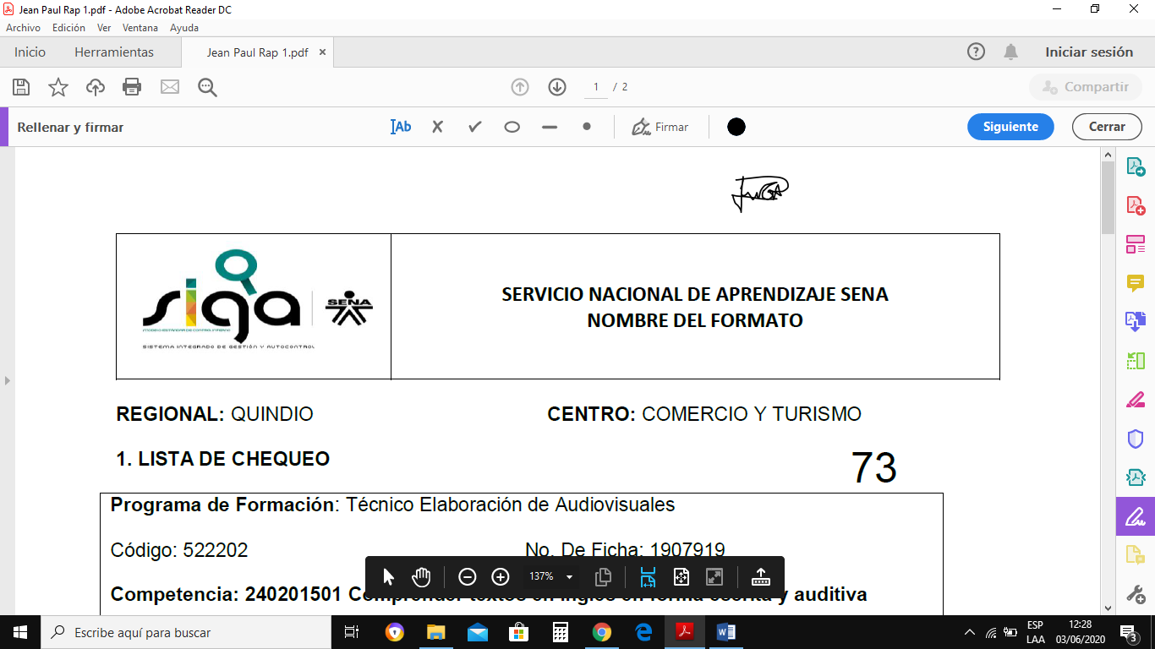

|  |  |
| --- | --- |
| _________________________________ | _________________________________ |
| Firma del Aprendiz | Firma del Instructor |